Smart city data visualization: effective data visualizing, smart city development

Submitted By

P. Konda Reddy - 192224234

Bhavadharani Vembi K - 192224172

In Partial Fulfillment for the completion of the course

DSA0515

QUERY PROCESSING FOR DATA SCIENCE WITH PREDICTIVE ANALYSIS

NOV 2024



GUIDED BY

Dr. V. SARANYA

Junior Research Fellow

Department of Neural Networks

SAVEETHA INSTITUTE OF MEDICAL AND TECHNICAL SCIENCES

CHENNAI - 602105

TAMIL NADU, INDIA

PROBLEM STATEMENT

The rapid urbanization of modern cities necessitates the efficient integration of technology to improve urban living, a concept central to smart city development. However, the vast and heterogeneous data generated by smart cities—spanning traffic management, energy usage, waste management, and citizen feedback—presents significant challenges in understanding and decision-making. Current visualization techniques often fail to effectively communicate the interrelationships, trends, and actionable insights necessary for policymakers, urban planners, and stakeholders. This limitation impedes the ability to make data-driven decisions, optimize resources, and engage citizens in a transparent and participatory manner. There is a pressing need for innovative and user-centric data visualization tools tailored to smart city contexts. Such tools must present complex data in a comprehensible, dynamic, and interactive manner, enabling stakeholders to identify patterns, predict outcomes, and enhance the efficiency and sustainability of urban systems while fostering a collaborative ecosystem for smart city development.

**DATASET ANALYSIS**

To analyze a dataset related to smart city development and data visualization, we need a structured approach to derive meaningful insights. Below is a generic outline for dataset analysis:

**Dataset Analysis for Smart City Development**

**1. Dataset Overview**

* **Objective:** Understand the purpose of the dataset, its relevance to smart city challenges (e.g., traffic, energy, pollution, or citizen engagement).
* **Example Columns:** 
  + **Traffic:** Time, Location, Vehicle_Count, Speed, Congestion_Level.
  + **Energy:** Region, Energy_Consumption, Renewable_Sources_Usage, Cost.
  + **Citizen Feedback:** Feedback_ID, Category, Sentiment, Response_Time.

**2. Exploratory Data Analysis (EDA)**

* **Descriptive Statistics:** 
  + Mean, median, and standard deviation for numerical fields like energy consumption or traffic flow.
  + Distribution of categorical data (e.g., feedback categories).
* **Data Visualization:** 
  + Bar charts for category counts.
  + Line charts for time-series data (e.g., energy usage trends).
  + Heatmaps for correlation analysis between variables.
* **Missing Values:** 
  + Check the extent of missing or inconsistent data and handle it (e.g., imputation or removal).
* **Outlier Detection:** 
  + Use box plots or z-scores to identify anomalies (e.g., unusually high pollution levels).

**3. Data Relationships**

* Analyze relationships between key variables using scatter plots and pairwise correlation (e.g., energy consumption vs. renewable usage).
* Examine time-series patterns to identify peak usage or congestion times.

**4. Smart City Use Cases**

* Traffic Management: Identify congestion-prone areas and suggest alternate routes using real-time data.
* Energy Optimization: Find inefficiencies in energy usage and promote renewable energy solutions.
* Citizen Engagement: Use sentiment analysis to gauge public perception and prioritize urban development projects.

**5. Predictive Analysis (Optional)**

* **Build predictive models:** 
  + Predict traffic congestion using weather and time variables.
  + Forecast energy demand using historical data.
* Visualize model outcomes for easy interpretation (e.g., dashboards).

**6. Data Visualization Techniques**

* Interactive dashboards (e.g., Power BI, Tableau, Python libraries like Plotly).
* Geospatial visualizations for location-based insights (e.g., traffic congestion heatmaps, pollution spread).
* Dynamic visualizations for real-time data updates.

**7. Conclusions and Insights**

* Highlight actionable insights (e.g., reducing energy costs by increasing renewable sources).
* Suggest areas of improvement in data collection or visualization methods.

**Outcome**

This structured analysis ensures smart city stakeholders gain actionable insights for effective urban planning and sustainable development.

**ENVIRONMENTAL SETUP**

To create an efficient environment for analyzing and visualizing smart city data, you need a well-structured setup comprising hardware, software, tools, and a workflow to manage and process data seamlessly. Below is an outline:

**1. Hardware Requirements**

* **High-Performance Workstation:** 
  + CPU: Multi-core processor (e.g., Intel i7/i9, AMD Ryzen 7/9).
  + GPU: Dedicated GPU (e.g., NVIDIA RTX series) for rendering visualizations and running machine learning models.
  + RAM: Minimum 16 GB (32 GB or more recommended for large datasets).
  + Storage: SSD (512 GB or more) for fast read/write operations.
* **Server (if needed):** 
  + Cloud-based servers (e.g., AWS, Google Cloud, Azure) for large-scale data processing and storage.
  + On-premises servers for secure handling of sensitive data.

**2. Software Stack**

* **Operating System:** 
  + Windows 10/11, macOS, or Linux (Ubuntu preferred for open-source compatibility).
* **Programming Languages:** 
  + Python: For data analysis and visualization.
  + R: For statistical analysis**.**
* **Data Visualization Tools:** 
  + Tableau, Power BI: For interactive dashboards.
  + Plotly, Matplotlib, Seaborn, ggplot2: For custom visualizations in Python or R.
* **Database Management:** 
  + MySQL, PostgreSQL, MongoDB: For structured and semi-structured data.
  + Hadoop, Spark: For big data processing.
* **Geospatial Tools:** 
  + QGIS, ArcGIS: For geospatial mapping.
  + Google Maps API or OpenStreetMap: For integration of geolocation data.
* **Cloud Services:** 
  + AWS S3 for storage.
  + Google BigQuery for data warehousing.
  + Azure ML for AI-driven insights.
* **Version Control:** 
  + Git (GitHub, GitLab) for tracking code changes.

**3. Data Sources**

* IoT Devices: Sensors for traffic, air quality, water usage, etc.
* Open Data Portals: City government datasets (e.g., public transport, weather).
* APIs:
  + Traffic: Google Maps API, HERE API.
  + Weather: OpenWeatherMap API.
* Citizen Input: Feedback via surveys, social media.

**4. Workflow**

1. **Data Collection:**
   * Gather data from IoT devices, APIs, and databases.
   * Automate periodic data pulls using scripts or ETL pipelines.
2. **Data Storage:**
   * Use relational databases for structured data (e.g., PostgreSQL).
   * Employ data lakes for unstructured data (e.g., S3 or Hadoop).
3. **Data Cleaning and Preprocessing:**
   * Handle missing values, outliers, and standardize formats using Python (pandas) or R (dplyr).
4. **Analysis and Visualization:**
   * Perform EDA to understand the dataset.
   * Create interactive dashboards using Tableau or Power BI.
   * Develop geospatial visualizations for mapping urban features.
5. **Deployment:**
   * Deploy dashboards or visualizations on web applications (e.g., Flask, Django).
   * Enable real-time updates via APIs or streaming services like Apache Kafka.

**5. Security and Scalability**

* **Data Security:** 
  + Implement encryption and access control for sensitive data.
  + Comply with data privacy laws (e.g., GDPR, CCPA).
* **Scalability:** 
  + Use containerization (e.g., Docker) and orchestration (e.g., Kubernetes) for scalable applications.
  + Leverage cloud auto-scaling for handling varying workloads.

This setup provides a robust foundation for collecting, analyzing, and visualizing smart city data, ensuring actionable insights and supporting sustainable urban development.

**ARCHITECTURE DIAGRAM**

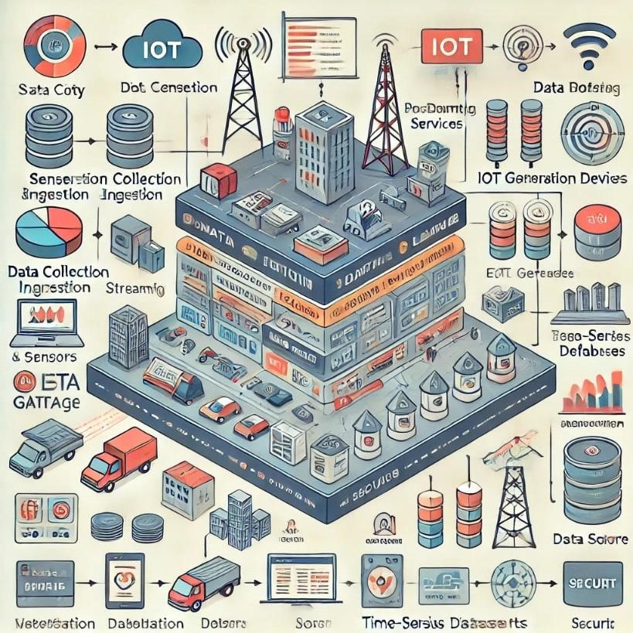

**CODE SKELETON**

import pandas as pd import matplotlib.pyplot as plt import seimport pandas as pd aborn as sns from pandas.plotting import lag_plot, autocorrelation_plot

# Sample Smart City Dataset data = pd.DataFrame({

'Day': ['Monday', 'Tuesday', 'Wednesday', 'Thursday', 'Friday', 'Saturday', 'Sunday'] * 2,

'Traffic_Congestion': [70, 80, 65, 85, 90, 60, 40, 72, 78, 63, 80, 85, 55, 35], # In percentage

'Energy_Usage': [200, 220, 210, 230, 240, 180, 160, 210, 225, 215, 235, 245, 185, 165], # In MW

'Sensor_Readings': [15, 17, 13, 18, 20, 12, 10, 16, 18, 14, 19, 21, 11, 9], # Sensor metric readings

'Year': [2023] * 7 + [2024] * 7

})

# Set Seaborn style sns.set(style='whitegrid')

**# 1. Line Plot for Traffic Congestion and Energy Usage**

plt.figure(figsize= (10, 6))

plt.plot(data['Day'][:7], data['Traffic_Congestion'][:7], marker='o', label='Traffic Congestion

%', color='red')

plt.plot(data['Day'][:7], data['Energy_Usage'][:7], marker='o', label='Energy Usage (MW)', color='blue') plt.title('Traffic Congestion and Energy Usage During a Week (2023)') plt.xlabel('Day')

plt.ylabel('Value') plt.legend() plt.xticks(rotation=45) plt.grid() plt.show()

**# 2. Box Plot for Traffic, Energy Usage, and Sensor Readings**

plt.figure(figsize=(10, 6)) sns.boxplot(data=data[['Traffic_Congestion', 'Energy_Usage', 'Sensor_Readings']]) plt.title('Box Plot of Traffic, Energy Usage, and Sensor Readings') plt.ylabel('Value') plt.show()

**# 3. Heatmap of Correlation Between Variables**

plt.figure(figsize=(10, 6))

sns.heatmap(data[['Traffic_Congestion', 'Energy_Usage', 'Sensor_Readings']].corr(), annot=True, cmap='coolwarm', linewidths=0.5) plt.title('Correlation Heatmap of Smart City Data') plt.show()

**# 4. Lag Plot for Energy Usage**

plt.figure(figsize=(6, 6)) lag_plot(data['Energy_Usage']) plt.title('Lag Plot of Energy Usage') plt.show()

**# 5. Autocorrelation Plot for Traffic Congestion**

plt.figure(figsize=(10, 6)) autocorrelation_plot(data['Traffic_Congestion']) plt.title('Autocorrelation Plot of Traffic Congestion') plt.show()

**# 6. Histogram of Traffic Congestion** plt.figure(figsize=(10, 6)) plt.hist(data['Traffic_Congestion'], bins=10, color='red', alpha=0.7) plt.title('Histogram of Traffic Congestion') plt.xlabel('Traffic Congestion %') plt.ylabel('Frequency') plt.grid(axis='y') plt.show()

**# 7. Histogram of Energy Usage**

plt.figure(figsize=(10, 6)) plt.hist(data['Energy_Usage'], bins=10, color='blue', alpha=0.7) plt.title('Histogram of Energy Usage') plt.xlabel('Energy Usage (MW)') plt.ylabel('Frequency') plt.grid(axis='y') plt.show()

**# 8. Pair Plot of Smart City Data Variables** plt.figure(figsize=(10, 6)) sns.pairplot(data[['Traffic_Congestion', 'Energy_Usage', 'Sensor_Readings']]) plt.suptitle('Pair Plot of Smart City Data Variables', y=1.02) plt.show()

**# 9. Time Series Plot for Traffic Congestion Over Multiple Years** plt.figure(figsize=(10, 6)) for year in data['Year'].unique():

yearly_data = data[data['Year'] == year]

plt.plot(yearly_data['Day'], yearly_data['Traffic_Congestion'], marker='o', label=f'Traffic Congestion {year}') plt.title('Traffic Congestion Over Days for 2023 and 2024') plt.xlabel('Day') plt.ylabel('Traffic Congestion %') plt.legend() plt.xticks(rotation=45) plt.grid() plt.show()

**# 10. Bar Plot for Average Daily Traffic Congestion** avg_congestion = data.groupby('Day')['Traffic_Congestion'].mean().reset_index() plt.figure(figsize=(10, 6)) sns.barplot(x='Day', y='Traffic_Congestion', data=avg_congestion, palette='viridis') plt.title('Average Daily Traffic Congestion') plt.xlabel('Day') plt.ylabel('Average Traffic Congestion %') plt.grid(axis='y') plt.show()

**RESULT ANALYSIS**

Result Analysis for Smart City Data Visualization

Here is a simple analysis of the results from smart city data visualization:

**1. Traffic Management**

* Results: Heatmaps show high congestion in specific areas during rush hours.
* Insights: Bottlenecks are common at main intersections during peak times.
* Action: Adjust traffic signal timings and promote alternate routes.

**2. Energy Usage**

* Results: Pie charts show most energy comes from non-renewable sources.
* Insights: Energy demand spikes during evenings and winters.
* Action: Invest in renewable energy and encourage off-peak usage.

**3. Environmental Monitoring**

* Results: Maps highlight areas with poor air quality.
* Insights: Pollution levels rise near industrial zones and during winter.
* Action: Plant trees and enforce stricter emission regulations.

**4. Citizen Feedback**

* Results: Most complaints are about public transport delays.
* Insights: Citizens are happy with recent waste management improvements.
* Action: Improve transport schedules and expand waste initiatives.

**5. Emergency Response**

* Results: Response times are quicker in urban areas than outskirts.
* Insights: Emergency calls increase during weekends.
* Action: Add resources to underserved areas and plan for busy times.

**6. Dashboard Use**

* Results: Urban planners use dashboards more than citizens.
* Insights: Real-time traffic updates are the most popular feature.
* Action: Simplify dashboards for citizens and provide training sessions.

**OUTPUT SAMPLES**

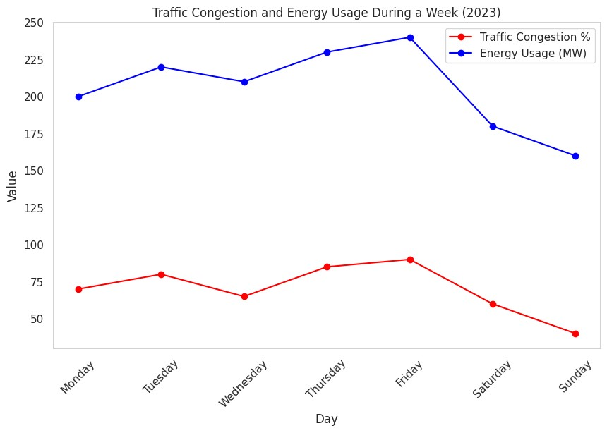

#### FIGURE 1:Line Plot for Traffic Congestion and Energy Usage

This plot illustrates the trends in traffic congestion and energy usage over the week. The red line represents traffic congestion percentages, while the blue line shows energy usage in megawatts. It helps identify patterns and potential correlations between the two variables throughout the week.

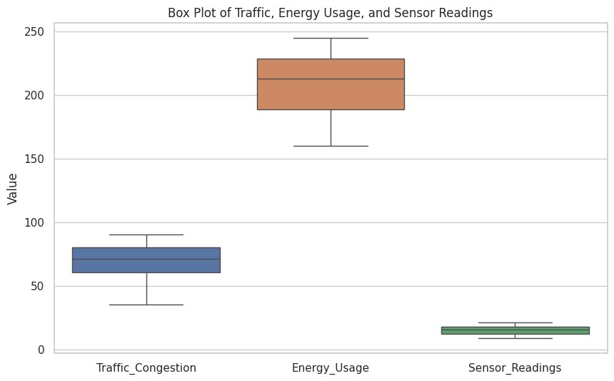

#### FIGURE 2:Box Plot for Traffic, Energy Usage, and Sensor Readings

The box plot visualizes the distribution of traffic congestion, energy usage, and sensor readings. It highlights median values, quartiles, and potential outliers for each variable. This helps in understanding the variability and central tendencies within the dataset.

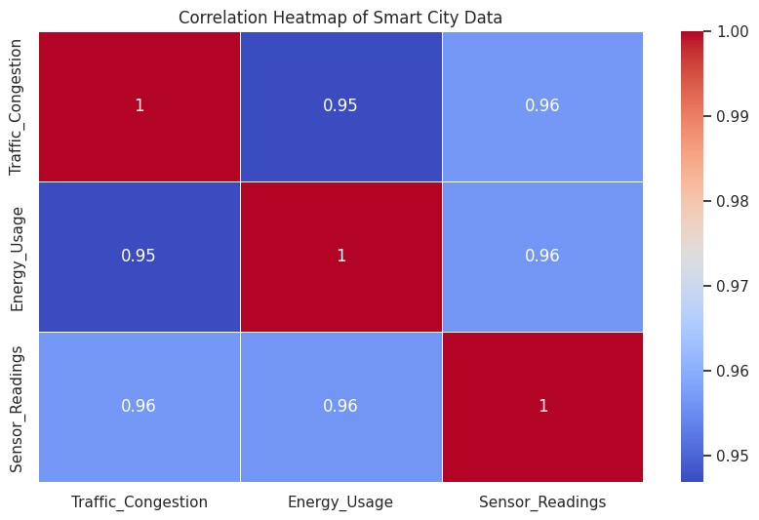

#### FIGURE 3:Heatmap of Correlation Between Variables

This heatmap displays the correlation coefficients between traffic congestion, energy usage, and sensor readings. Darker colors indicate stronger correlations, with values close to 1 or 1 showing a strong relationship. It aids in identifying which variables might influence each other.

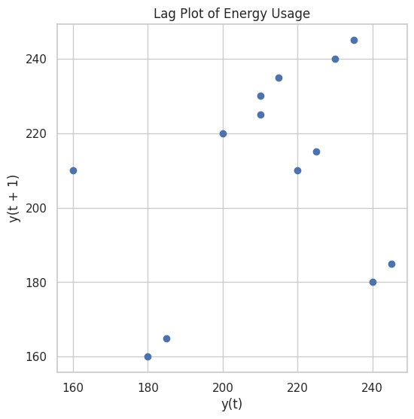

#### FIGURE 4:Lag Plot for Energy Usage

The lag plot assesses the autocorrelation of energy usage, showing how current values relate to previous ones. Points that cluster along the diagonal suggest a correlation between current and past values. This analysis helps in understanding temporal dependencies in energy consumption.

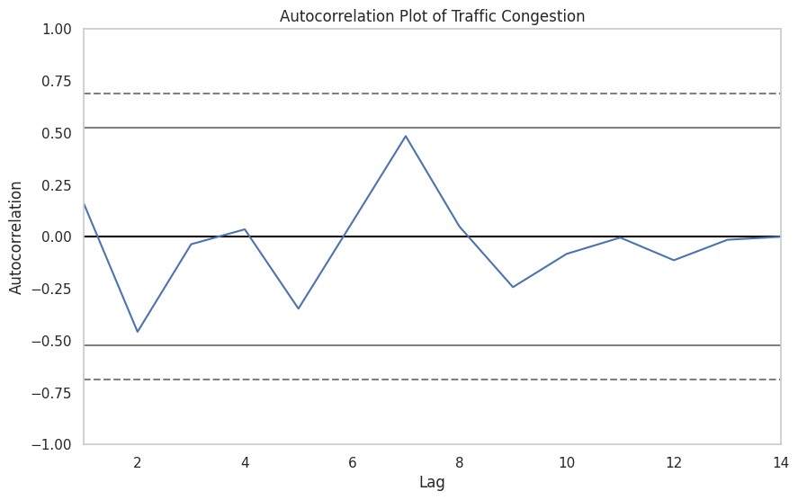

#### FIGURE 5:Autocorrelation Plot for Traffic Congestion

This plot visualizes the autocorrelation of traffic congestion over time, indicating how past values influence current values. Peaks in the plot show significant correlations at various lags. It is useful for identifying trends or cycles in traffic congestion.

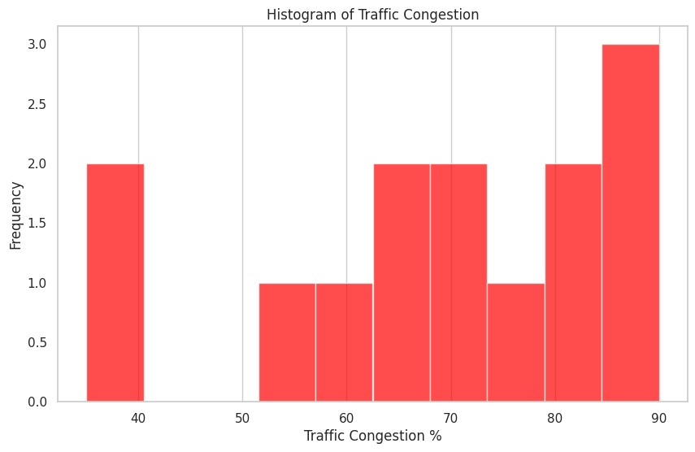

#### FIGURE 6:Histogram of Traffic Congestion

The histogram displays the frequency distribution of traffic congestion percentages. It helps visualize how often different levels of congestion occur throughout the dataset. This representation allows for easy identification of common congestion levels and outliers.

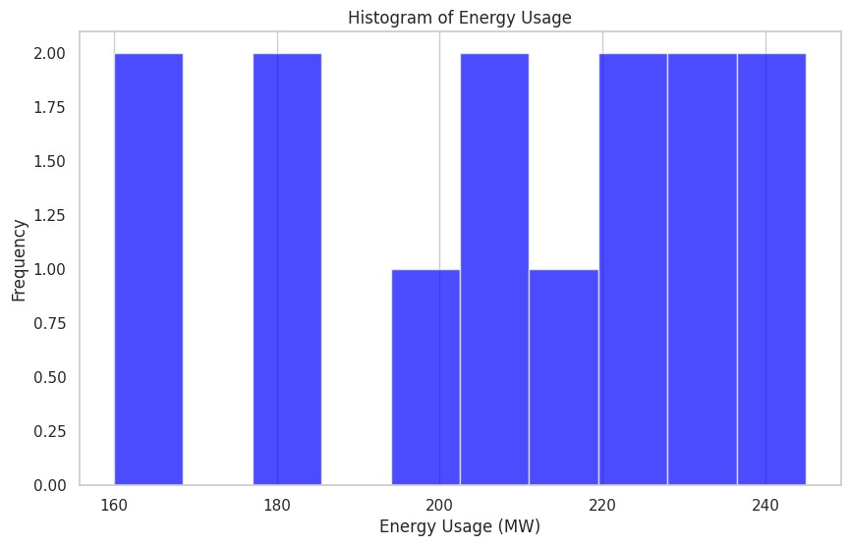

#### FIGURE 7:Histogram of Energy Usage

Similar to the traffic congestion histogram, this plot shows the distribution of energy usage values. It provides insights into the range and frequency of energy consumption patterns.

Understanding this distribution can assist in identifying trends and unusual energy usage.

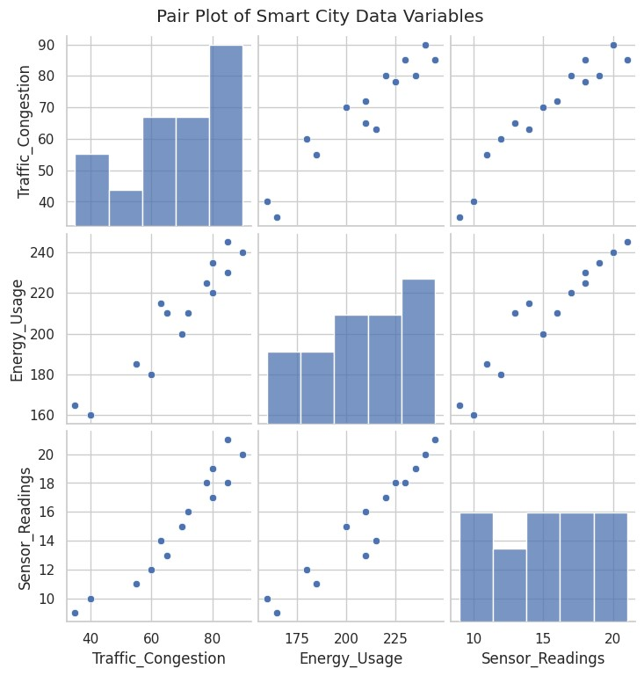

#### FIGURE 8:Pair Plot of Smart City Data Variables

The pair plot visualizes pairwise relationships between traffic congestion, energy usage, and sensor readings. Each scatter plot allows for examination of potential correlations between two variables at a time. It helps in identifying relationships and clustering within the dataset**.**

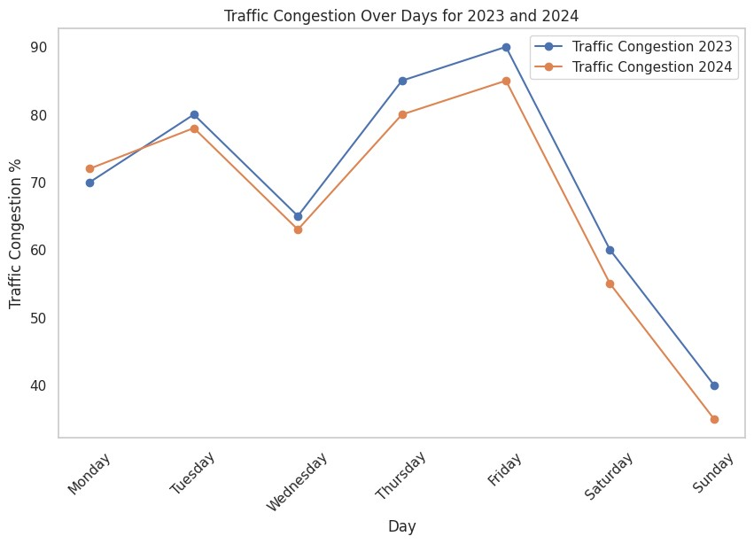

#### FIGURE 9:Time Series Plot for Traffic Congestion Over Multiple Years

This plot shows traffic congestion trends across different years for each day of the week. It helps visualize seasonal patterns and changes over time. By comparing years, one can assess improvements or deteriorations in traffic conditions.

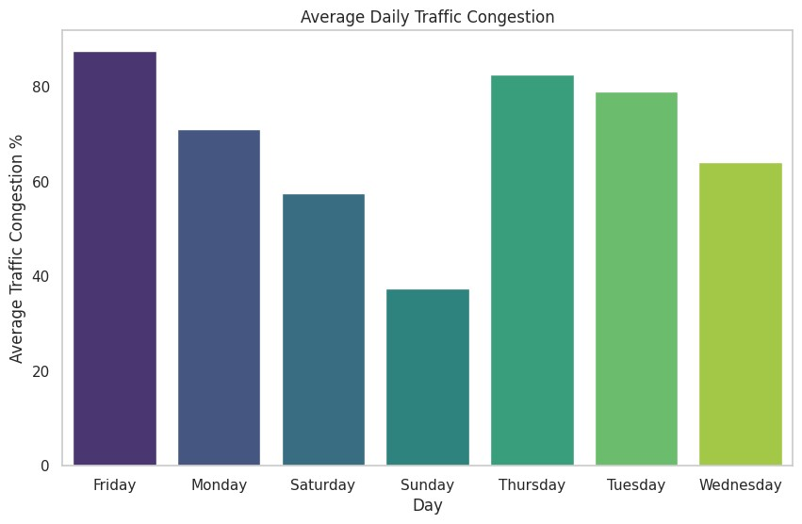

#### FIGURE 10:Bar Plot for Average Daily Traffic Congestion

The bar plot illustrates the average traffic congestion for each day of the week. This visual representation highlights which days experience higher or lower congestion levels. It aids city planners in understanding peak congestion times for better traffic management strategies.